

**MUSIC WORLD**

**E-Project Documentation**

**Teacher Name: SIR KAIF**

**APTECH COMPUTER EDUCATION**

**LATIFABAD PAKISTAN**

**Issue Date: 23-MARCH-25**

TABLE OF CONTENT

|  |  |  |
| --- | --- | --- |
| **S No** | **Contents** | **Page No** |
| 01 | Certificate | 3 |
| 02 | Acknowledgement | 4 |
| 03 | Project Report | 5 |
| 04 | Problem Definition | 6 |
| 05 | Customer Requirements Specification  (CRS) | 7 |
| 06 | Architecture Design of the Project | 8 |
| 07 | System Requirement | 9 |
| 08 | Task Sheet | 10 |
| 09 | Project Plan | 11 |
| 10 | Checklist of work Progress | 12 |
| 11 | Final Check List | 13 |
| 12 | Screen Shots | 14 |
| 13 | Source Code | 16 |

CERTIFICATE

This is to certify that

**SAADATULLAH,**

**ZAIN-UL-ABIDEEN,**

**USAID,**

Submitted by:

**ALL GROUP MEMBERS**

Has successfully Designed

**STAR ORGANIC FARM**

Date of Issue: 23**-MARCH-25**

Authorized Signature: SIR KAIF

ACKNOWLEDGEMENT

First and foremost, we would like to express our deep gratitude and most heartfelt thanks to almighty ALLAH for his blessings, for lightening up our heart with the torch of knowledge and for giving us the ability to complete this project.

We would like to thanks Aptech Worldwide and the team of E-Project for their generous support and clarifying the doubts regarding e-project. We would like to acknowledge the way of explanation which the team of e-project gave in e-project to make website and we are equally grateful to our teacher (SIR RAJESH) for giving us a moral support and guiding us different matters regarding project in all the time about the research and writing of this project.

We are greatly indebted to Aptech Worldwide, SIR RAJESH, Faculty Members and ACE Hyderabad, Pakistan for encouragement and incessant help.

PROJECT REPORT

**BY:**

**Student1626456__SAADATULLAH**

**Student1623500 __ZAIN-UL-ABIDEEN,**

**Student1623496 __ USAID,**

Project Title:

STAR ORGANIC FARM

Members Name:

**SAADATULLAH**,

**ZAIN-UL-ABIDEEN**,

**USAID**,

Batch Code: 2411E

Start Date: 23-MARCH -2025

End Date: 21-APRIL -2025

Course: ACCP-PRIME (CPISM-1)

Teacher: SIR KAIF

Center Manager: Sir Shoaib Ahmed

Center Academic Head: Sir Shoaib Ahmed

Center Name: LATIFABAD, Pakistan

Submitted as

E Project Documentation

**OBJECTIVES & AIM**

The Objective of this program is to give a sample project to work on real life

projects. These applications help you build a larger more robust application.

The objective is not to teach you the software’s but to provide you with a real life

scenario and help you create basic applications using the tools.

You can revise the topics before you start with the project.

These programs should be done in the Lab sessions with assistance of the faculty if

required.

It is very essential that a student has a clear understanding of the subject.

Kindly get back to projects Team in case of any doubts regarding the

application or its objectives.

**PROBLEM STATEMENT**

**Introduction**

The problem statement is attached separately in a file “FurnitureSystem.doc”

**Standards plan:**

Every code block must have comments.

The logic of the program needs to be explained. Proper documentation should be

maintained.

Complete Project Report along with synopsis, code and documentation should be

prepared.

**Documentation**

No project is complete without documentation. In fact, it is one of the most

important activities during the development of a project. The documentation of an

ideal project will be in the form of a project report comprising of the following

documents:

`

* Certificate of Completion.
* Table of Contents.
* Problem Definition.
* Customer Requirement Specification.
* Project Plan.
* E-R Diagrams.
* Algorithms.
* GUI Standards Document.
* Interface Design Document.
* Task Sheet.
* Project Review and Monitoring Report.
* Unit Testing Check List.
* Final Check List.

**Deliverables**

**You need to submit the following Deliverables:**

**1. Documentation of the project.**

**2.You need to follow all the following points as a part of your**

**projects execution process**

**a) Send us 2 (two) projects status mail, each should be after 10**

**days interval from your projects start date. Incase if your project**

**is less than 30 days then also you need to send 2 (two) status**

**mails (first status mail between 7-10 days and second 3 days**

**before the end date of project).**

**b) The status mail should consist of description with review document**

**(what's going on the project). Also you can send your doubts / clarification or**

**any additional inputs required to complete your project any time during the**

**project planning and execution.**

**c) At the time of project submission also send us the feedback along**

**with your documentation (soft copy). The Feedback form is**

**attached with this mail.**

Architecture & Design of the Project:

Since the website will have client architecture it will have one-tier architecture.

System Requirement:

**Hardware/ Software Requirements**

**Hardware**

* A minimum computer system that will help you access all the tools in the courses is a Pentium 166 or better
* 64 Megabytes of RAM or better

**Software *[Either or Combination as per Course/Sem]***

* Notepad/HTML editor/Coffee Cup
* Angular / Angular JS / React / Bootstrap
* Dreamweaver / Figma
* MS IE / Chrome / FireFox / Netscape /MS Edge

TASK SHEET

|  |  |  |  |  |  |
| --- | --- | --- | --- | --- | --- |
| **Project Ref. No:** | | **Date of Preparation of Activity Plan:** | | | |
| Sr.no | Task | Actual  Start Date: | Actual  Day: | Team  Mates Names: | Status: |
| 01 | Meeting | 5 APRIL, 2025 | 1 | SAADATULLAH,  ZAIN-UL-ABIDEEN,  USAID, |  |
| 02 | Data  Collection | 7 APRIL, 2025 | 1 | SAADATULLAH,  ZAIN-UL-ABIDEEN,  USAID, |  |
| 03 | Designing  Home  Page | 10 APRIL,2025 | 3 | SAADATULLAH,  ZAIN-UL-ABIDEEN,  USAID, |  |
| 04 | Linking | 11APRIL, 2025 | 1 | SAADATULLAH,  ZAIN-UL-ABIDEEN,  USAID, |  |
| 05 | Check  Links | 14,APRIL , 2025 | 1 | SAADATULLAH,  ZAIN-UL-ABIDEEN,  USAID, |  |
| 06 | Navbar | 16,DEC, 2024 | 1 | SAADATULLAH,  ZAIN-UL-ABIDEEN,  USAID, |  |
| 06 | Finalizing | 18,APRIL , 2025 | 2 | SAADATULLAH,  ZAIN-UL-ABIDEEN,  USAID, |  |
| 08 | Documentation | 19,APRIL , 2025 | 1 | SAADATULLAH,  ZAIN-UL-ABIDEEN,  USAID, |  |
| 09 | Uploading | 21,APRIL, 2025 | 4 | SAADATULLAH,  ZAIN-UL-ABIDEEN,  USAID, |  |

PROJECT PLAN

* Website is able to execute quickly.
* The color combination of our website is so attractive.
* The collection of data is authentic and taken by the most popular product websites.
* Background of each page is as same as the main page.
* The contact page is well prepared exactly for the same page as user clicks on the link...
* A user can resolve its difficulties easily from this site.

CHECK LIST OF WORK PROGRESS

|  |  |  |
| --- | --- | --- |
| **SR. No** | **Aspect Tested** | **Remarks** |
| 01 | Data Collection |  |
| 02 | Designing Home Page |  |
| 03 | Linking The Pages |  |
| 04 | Designing Other Pages |  |
| 05 | Finalization |  |
| 06 | Documentation |  |

FINAL CHECK LIST

|  |  |  |  |
| --- | --- | --- | --- |
| **SR.No** | **Particulars** | **Yes** | **No** |
| 01 | Do all pages open? | YES |  |
| 02 | Are all hyperlinks working? | YES |  |
| 03 | Are the web page contents devoid for  spelling mistakes? |  | No |
| 04 | Are all the web components working? | YES |  |
| 05 | Is site browser compatible? | YES |  |

SCREEN SHOTS:

HOME PAGE

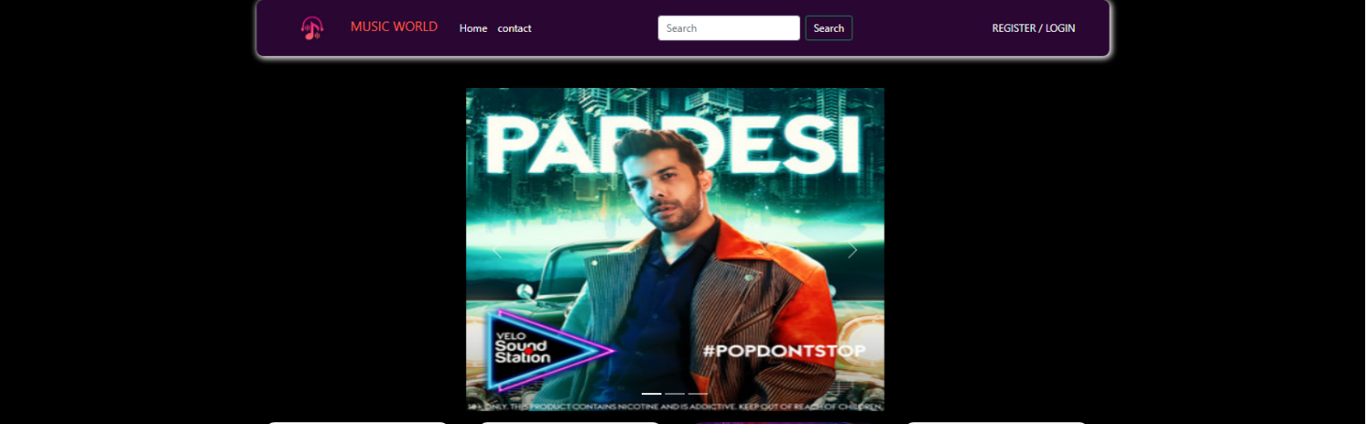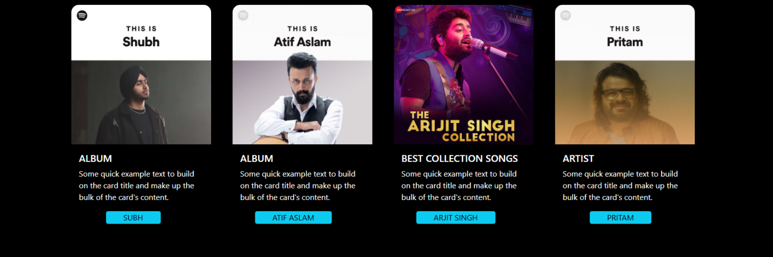

# 

ABOUT US PAGE

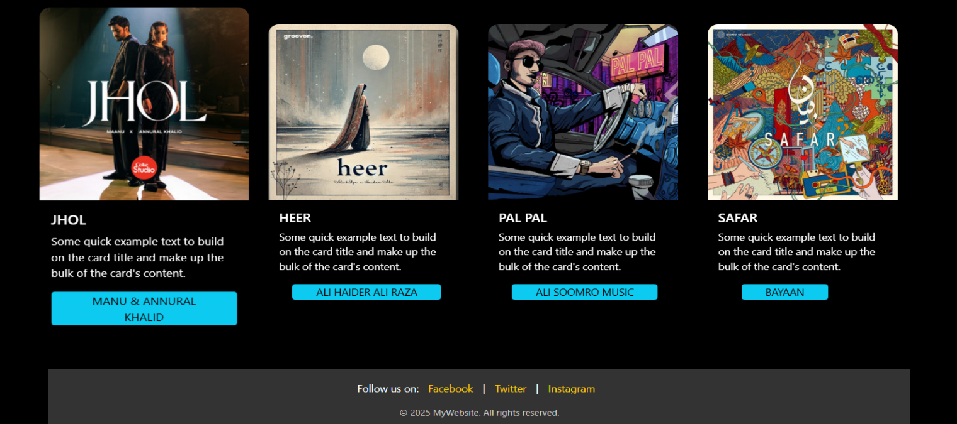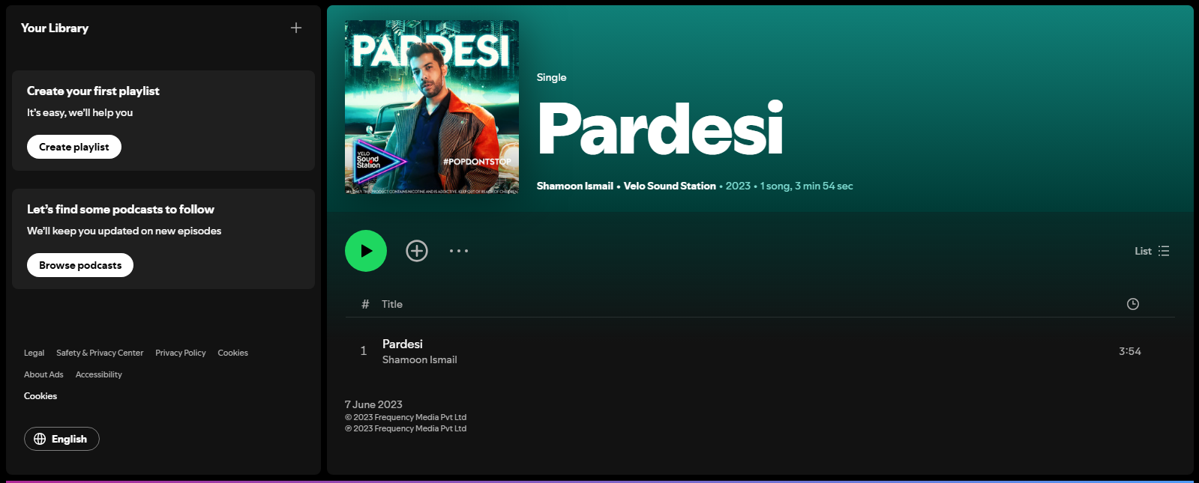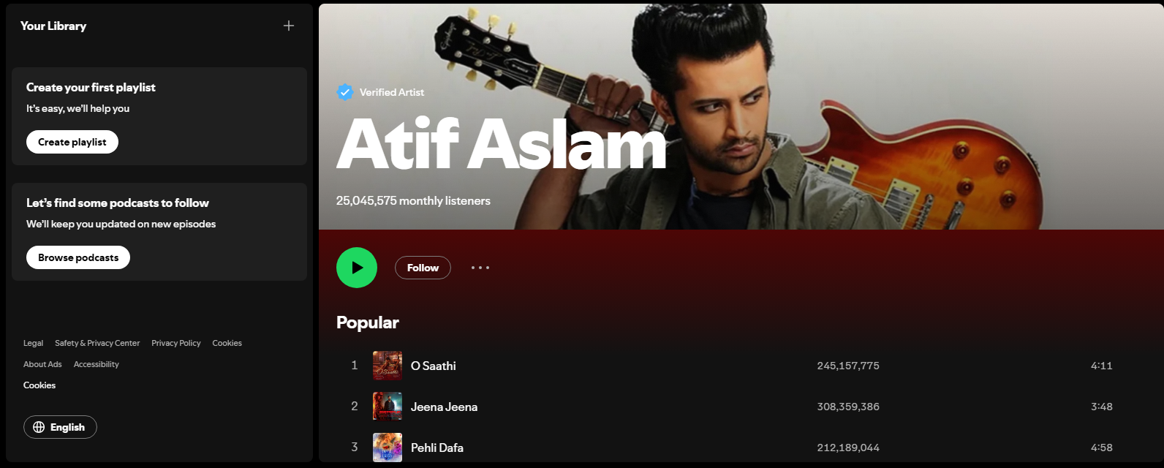

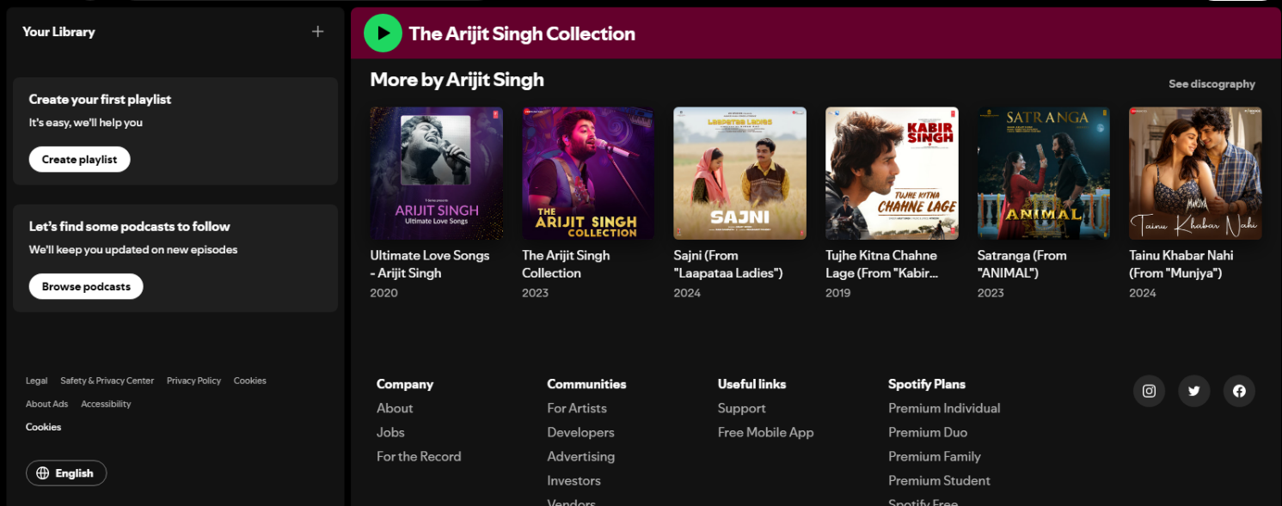

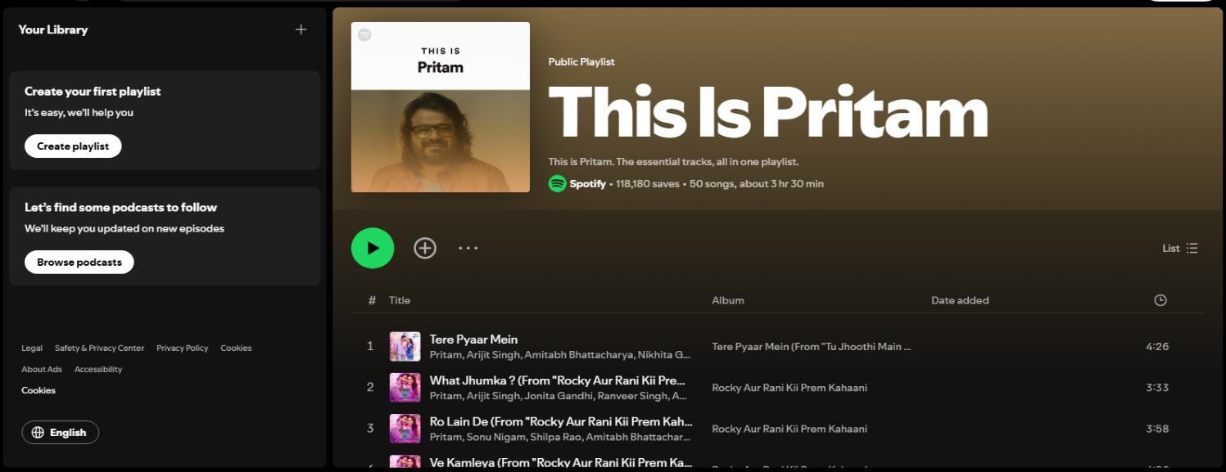

FORM PAGE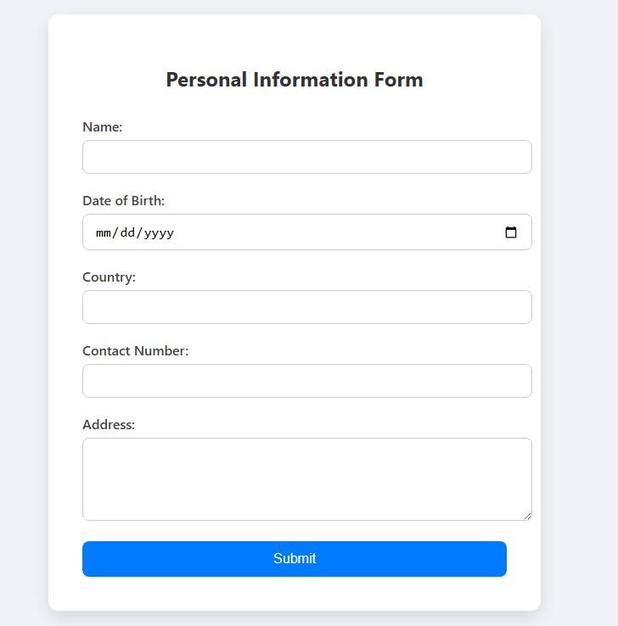

FORM PAGE

SOURCE CODE:

HTML,CSS : HOME PAGE

<!DOCTYPE html>

<html lang="en">

<head>

  <meta charset="UTF-8">

  <title>Personal Information Form</title>

  <style>

    body {

      font-family: 'Segoe UI', Tahoma, Geneva, Verdana, sans-serif;

      background: #f0f2f5;

      margin: 0;

      padding: 0;

      display: flex;

      justify-content: center;

      align-items: center;

      height: 100vh;

    }

    .form-container {

      background: #ffffff;

      padding: 40px;

      border-radius: 12px;

      box-shadow: 0 8px 20px rgba(0, 0, 0, 0.1);

      width: 100%;

      max-width: 500px;

    }

    h2 {

      text-align: center;

      margin-bottom: 30px;

      color: #333;

    }

    label {

      display: block;

      margin-bottom: 6px;

      font-weight: 500;

      color: #444;

    }

    input[type="text"],

    input[type="date"],

    input[type="tel"],

    textarea {

      width: 100%;

      padding: 10px 14px;

      margin-bottom: 20px;

      border: 1px solid #ccc;

      border-radius: 8px;

      font-size: 16px;

      transition: border-color 0.3s;

    }

    input:focus,

    textarea:focus {

      border-color: #007bff;

      outline: none;

    }

    textarea {

      resize: vertical;

    }

    button {

      width: 100%;

      padding: 12px;

      background-color: #007bff;

      color: white;

      border: none;

      border-radius: 8px;

      font-size: 16px;

      cursor: pointer;

      transition: background-color 0.3s;

    }

    button:hover {

      background-color: #0056b3;

    }

  </style>

</head>

<body>

  <div class="form-container">

    <h2>Personal Information Form</h2>

    <form action="/submit" method="POST">

      <label for="name">Name:</label>

      <input type="text" id="name" name="name" required>

      <label for="dob">Date of Birth:</label>

      <input type="date" id="dob" name="dob" required>

      <label for="country">Country:</label>

      <input type="text" id="country" name="country" required>

      <label for="contact">Contact Number:</label>

      <input type="tel" id="contact" name="contact" pattern="[0-9]{10,15}" required>

      <label for="address">Address:</label>

      <textarea id="address" name="address" rows="4" required></textarea>

      <button type="submit">Submit</button>

    </form>

  </div>

</body>

</html>

<!DOCTYPE html>

<html lang="en">

  <head>

    <meta charset="UTF-8" />

    <meta name="viewport" content="width=device-width, initial-scale=1.0" />

    <title>Document</title>

    <link

      href="https://cdn.jsdelivr.net/npm/bootstrap@5.0.2/dist/css/bootstrap.min.css"

      rel="stylesheet"

      integrity="sha384-EVSTQN3/azprG1Anm3QDgpJLIm9Nao0Yz1ztcQTwFspd3yD65VohhpuuCOmLASjC"

      crossorigin="anonymous"

    />

    <script

      src="https://cdn.jsdelivr.net/npm/bootstrap@5.0.2/dist/js/bootstrap.bundle.min.js"

      integrity="sha384-MrcW6ZMFYlzcLA8Nl+NtUVF0sA7MsXsP1UyJoMp4YLEuNSfAP+JcXn/tWtIaxVXM"

      crossorigin="anonymous"

    ></script>

    <style>

      body {

        background-color: black;

      }

      .navbar {

        border-radius: 10px;

        box-shadow: 2px 2px 10px 2px;

        background-color: transparent;

        color: white;

        background-color: #2a0632;

      }

      .navbar-brand img {

        border-radius: 60%;

      }

      .navbar a {

        color: white;

      }

      .nav-link:hover {

        text-decoration: underline;

        transition: 1s;

        color: blue;

      }

      .carousel-inner img {

        width: 1100px;

        height: 500px;

      }

      #cl{

        margin-left: 300px;

      }

      .card{

        height: 50vh;

        overflow: hidden;

        border-radius: 16px;

      }

      .card{

        object-fit: cover;

        transition: transform 0.08s;

        height: 80vh;

      }

      .card:hover{

        transform: scale(1.1);

       }

       .btn-info:hover{

        background-color: black;

        color: white;

        transition: 1s;

       }

       footer {

      background-color: #333; /* Dark background */

      color: white; /* White text */

      padding: 20px 0; /* Vertical padding */

      text-align: center; /* Centered content */

      position: relative;

      bottom: 0;

      width: 100%;

    }

    /* Links inside the footer */

    footer a {

      color: #ffcc00; /* Golden color for links */

      text-decoration: none;

      margin: 0 10px;

    }

    /* Hover effect for footer links */

    footer a:hover {

      text-decoration: underline;

    }

    /* Copyright text styling */

    .footer-bottom {

      margin-top: 10px;

      font-size: 14px;

      color: #ccc;

    }

      /* .carousel-inner{

        height: 50vh;

        overflow: hidden;

        border-radius: 16px;

      }

      .carousel-inner img{

        object-fit: cover;

        transition: transform 0.08s;

        height: 80vh;

      }

      .carousel-inner img:hover {

        transform: scale(1.1); */

       */

    </style>

  </head>

  <body>

    <div class="container">

      <div class="col">

        <div class="row">

          <nav class="navbar navbar-expand-lg">

            <div class="container-fluid">

              <a class="navbar-brand" href="#"

                ><img

                  src="https://th.bing.com/th/id/OIP.tbqUFi1STgHWk3mSci02cAHaFj?w=316&h=190&c=7&r=0&o=5&pid=1.7"

                  width="100px"

                  alt=""

                /><span style="color: tomato; margin: 10px"

                  >MUSIC WORLD

                </span></a

              >

              <button

                class="navbar-toggler"

                type="button"

                data-bs-toggle="collapse"

                data-bs-target="#navbarSupportedContent"

                aria-controls="navbarSupportedContent"

                aria-expanded="false"

                aria-label="Toggle navigation"

              >

                <span class="navbar-toggler-icon"></span>

              </button>

              <div class="collapse navbar-collapse" id="navbarSupportedContent">

                <ul class="navbar-nav me-auto mb-2 mb-lg-0">

                  <li class="nav-item">

                    <a class="nav-link active" aria-current="page" href="index.html"

                      >Home</a

                    >

                  </li>

                  <li class="nav-item">

                    <!-- <a class="nav-link" href="music.html">music </a> -->

                  </li>

                  <li class="nav-item dropdown">

                    <!-- <a

                      class="nav-link dropdown-toggle"

                      href="about.html"

                      id="navbarDropdown"

                      role="button"

                      data-bs-toggle="dropdown"

                      aria-expanded="false"

                    >

                      about

                    </a> -->

                  </li>

                  <li class="nav-item">

                    <!-- <a class="nav-link" href="contact.html">contact</a> -->

                  </li>

                </ul>

                <form class="d-flex" style="margin-right: 200px">

                  <input

                    class="form-control me-2"

                    type="Search"

                    placeholder="Search"

                    aria-label="Search"

                  />

                  <button

                    class="btn btn-outline-success"

                    type="submit "

                    style="color: white"

                  >

                    Search

                  </button>

                </form>

                <a class="nav-link" href="form.html" style="color: white"

                  >REGISTER / LOGIN</a

                >

              </div>

            </div>

          </nav>

        </div>

      </div>

      <div class="row" id="cl">

        <div class="col-8">

          <div

            id="carouselExampleIndicators"

            class="carousel slide"

            data-bs-ride="true"

            style="margin-top: 50px"

          >

            <div class="carousel-indicators">

              <button

                type="button"

                data-bs-target="#carouselExampleIndicators"

                data-bs-slide-to="0"

                class="active"

                aria-current="true"

                aria-label="Slide 1"

              ></button>

              <button

                type="button"

                data-bs-target="#carouselExampleIndicators"

                data-bs-slide-to="1"

                aria-label="Slide 2"

              ></button>

              <button

                type="button"

                data-bs-target="#carouselExampleIndicators"

                data-bs-slide-to="2"

                aria-label="Slide 3"

              ></button>

            </div>

            <div class="carousel-inner">

              <div class="carousel-item active">

                <a href="https://open.spotify.com/album/4pa9j1sjBWANSmeRGrO1qS"><img

                  src="https://i.scdn.co/image/ab67616d00001e02b3324226fff32253c395509a"

                  class="d-block w-100"

                  alt="..."

                /></a>

              </div>

              <div class="carousel-item">

                <a href="https://open.spotify.com/album/0KD9Ddk52NSmYdzW8QcgFY"><img src="https://i.scdn.co/image/ab67616d00001e02208e53a40851349531c90286" class="d-block w-100" alt="..." /></a>

              </div>

              <div class="carousel-item">

               <a href="https://open.spotify.com/album/4JsZodknDILTDTnswlIYIf"><img src="https://i.scdn.co/image/ab67616d00001e029f93eb31e6caa86dd5f65f51" class="d-block w-100" alt="..." /></a>

              </div>

            </div>

            <button

              class="carousel-control-prev"

              type="button"

              data-bs-target="#carouselExampleIndicators"

              data-bs-slide="prev"

            >

              <span

                class="carousel-control-prev-icon"

                aria-hidden="true"

              ></span>

              <span class="visually-hidden">Previous</span>

            </button>

            <button

              class="carousel-control-next"

              type="button"

              data-bs-target="#carouselExampleIndicators"

              data-bs-slide="next"

            >

              <span

                class="carousel-control-next-icon"

                aria-hidden="true"

              ></span>

              <span class="visually-hidden">Next</span>

            </button>

          </div>

        </div>

        <div class="col-4">

        </div>

      </div>

      <!-- CARD -->

      <div class="row">

        <!-- CARD 1 -->

        <div class="col mt-3">

          <div class="card" style="width: 18rem;background: #000; color: #fff;">

            <a href="https://open.spotify.com/playlist/37i9dQZF1DZ06evO3ckHLO"><img class="card-img-top" src="https://thisis-images.spotifycdn.com/37i9dQZF1DZ06evO3ckHLO-default.jpg" alt="Card image cap"></a>

            <div class="card-body">

              <h5 class="card-title"> ALBUM </h5>

              <p class="card-text">Some quick example text to build on the card title and make up the bulk of the card's content.</p>

              <a href="#" class="btn btn-info " style="padding: 0 35px 0 35px; margin-left: 55px;"> SUBH</a>

            </div>

          </div>

        </div>

        <!-- CARD-2 -->

        <div class="col mt-3">

          <div class="card" style="width: 18rem; background: #000; color: #fff;">

            <a href="https://open.spotify.com/artist/2oSONSC9zQ4UonDKnLqksx"><img class="card-img-top" src="https://thisis-images.spotifycdn.com/37i9dQZF1DZ06evO1n6IJz-default.jpg" alt="Card image cap"></a>

            <div class="card-body">

              <h5 class="card-title"> ALBUM </h5>

              <p class="card-text">Some quick example text to build on the card title and make up the bulk of the card's content.</p>

              <a href="#" class="btn btn-info " style="padding: 0 35px 0 35px; margin-left: 30px;"> ATIF ASLAM</a>

            </div>

          </div>

        </div>

          <!-- CARD-3 -->

        <div class="col mt-3">

          <div class="card" style="width: 18rem;background: #000; color: #fff;">

            <a target="_blank" href="https://open.spotify.com/album/1QOwvBk3LNWAaEvARxPDNd"><img class="card-img-top" src="https://i.scdn.co/image/ab67616d00001e02627b5b17cb48f6e6956b842e" alt="Card image cap"></a>

            <div class="card-body">

              <h5 class="card-title">BEST COLLECTION SONGS</h5>

              <p class="card-text">Some quick example text to build on the card title and make up the bulk of the card's content.</p>

              <a href="#" class="btn btn-info"  style="padding: 0 35px 0 35px; margin-left: 30px;">ARJIT SINGH</a>

            </div>

          </div>

        </div>

        <!-- CARD-4 -->

        <div class="col mt-3">

          <div class="card" style="width: 18rem;background: #000; color: #fff;">

            <a href="https://open.spotify.com/playlist/37i9dQZF1DZ06evO0QBBOU"><img class="card-img-top" src="https://thisis-images.spotifycdn.com/37i9dQZF1DZ06evO0QBBOU-default.jpg" alt="Card image cap"></a>

            <div class="card-body">

              <h5 class="card-title">ARTIST</h5>

              <p class="card-text">Some quick example text to build on the card title and make up the bulk of the card's content.</p>

              <a href="#" class="btn btn-info" style="padding: 0 35px 0 35px; margin-left: 55px;">PRITAM</a>

            </div>

          </div>

        </div>

           <!-- CARD-5 -->

        <div class="col mt-3">

          <div class="card" style="width: 18rem;background: #000; color: #fff;">

            <a href="https://open.spotify.com/track/7mCh0uF0iW7AuDr7pZro21"><img class="card-img-top" src="https://i.scdn.co/image/ab67616d00001e028c2440bff39213bcf61b07c0" alt="Card image cap"></a>

            <div class="card-body">

              <h5 class="card-title">SUKOON</h5>

              <p class="card-text">Some quick example text to build on the card title and make up the bulk of the card's content.</p>

              <a href="#" class="btn btn-info" style="padding: 0 35px 0 35px; margin-left: 15px;">HASSAN & ROSHAAN</a>

            </div>

          </div>

        </div>

          <!-- CARD-6 -->

        <div class="col mt-3">

          <div class="card" style="width: 18rem;background: #000; color: #fff;">

            <a href="https://open.spotify.com/track/6eeinYVA4kc7ZkN7irTmzK"><img class="card-img-top" src="https://i.scdn.co/image/ab67616d00001e02bd15d17981337ceb9b5b8d93" alt="Card image cap"></a>

            <div class="card-body">

              <h5 class="card-title">AAYI AAYI</h5>

              <p class="card-text">Some quick example text to build on the card title and make up the bulk of the card's content.</p>

              <a href="#" class="btn btn-info " style="padding: 0 35px 0 35px; margin-left: 20px;">NOMAN ALI RAJPER</a>

            </div>

          </div>

        </div>

          <!-- CARD-7 -->

        <div class="col mt-3">

          <div class="card" style="width: 18rem;background: #000; color: #fff;">

            <a href="https://open.spotify.com/track/6dPCsJmys61wAVJIfsRPXi"><img class="card-img-top" src="https://i.scdn.co/image/ab67616d00001e021d9d5dc54ac1752ea7b6f234" alt="Card image cap"></a>

            <div class="card-body">

              <h5 class="card-title">DO PAL</h5>

              <p class="card-text">Some quick example text to build on the card title and make up the bulk of the card's content.</p>

              <a href="#" class="btn btn-info" style="padding: 0 35px 0 35px; margin-left: 25px;">COACHSAHB</a>

            </div>

          </div>

        </div>

         <!-- CARD-8 -->

        <div class="col mt-3">

          <div class="card" style="width: 18rem;background: #000; color: #fff;">

            <a href="https://open.spotify.com/album/3I8PdIhk6pNm8Kv0HiF14V"><img class="card-img-top" src="https://i.scdn.co/image/ab67616d00001e02ba03ff79dad25f7c3542382f" alt="Card image cap"></a>

            <div class="card-body">

              <h5 class="card-title">TUJHE KITNA CHAHNE LAGE</h5>

              <p class="card-text">Some quick example text to build on the card title and make up the bulk of the card's content.</p>

              <a href="#" class="btn btn-info" style="padding: 0 35px 0 35px; margin-left: 25px;">ARIJIT SINGH & MITHOON</a>

            </div>

          </div>

        </div>

        <!-- CARD-9 -->

        <div class="col mt-3">

          <div class="card" style="width: 18rem;background: #000; color: #fff;">

            <a href="https://open.spotify.com/album/7grtFo2pj5wwRTM7c6NI9y?highlight=spotify:track:4XTgFBxBHN6var1BzAgE1m"><img class="card-img-top" src="https://i.scdn.co/image/ab67616d00001e021344800458a38197bfc721f3" alt="Card image cap"> </a>

            <div class="card-body">

              <h5 class="card-title">JHOL</h5>

              <p class="card-text">Some quick example text to build on the card title and make up the bulk of the card's content.</p>

              <a href="#" class="btn btn-info" style="padding: 0 35px 0 35px; margin-left: 0px;">MANU & ANNURAL KHALID</a>

            </div>

          </div>

        </div>

         <!-- CARD-10 -->

        <div class="col mt-3">

          <div class="card" style="width: 18rem;background: #000; color: #fff;">

            <a href="https://open.spotify.com/album/27XIdXAZ9IJ9UGqVjJzOcm?highlight=spotify:track:2618Fg2I7K5leCzDUhOjbr"><img class="card-img-top" src="https://i.scdn.co/image/ab67616d00001e02096e2a4581cab7a4bba393c3" alt="Card image cap"></a>

            <div class="card-body">

              <h5 class="card-title">HEER</h5>

              <p class="card-text">Some quick example text to build on the card title and make up the bulk of the card's content.</p>

              <a href="#" class="btn btn-info" style="padding: 0 35px 0 35px; margin-left: 20px;">ALI HAIDER ALI RAZA </a>

            </div>

          </div>

        </div>

        <!-- CARD-11 -->

        <div class="col mt-3">

          <div class="card" style="width: 18rem;background: #000; color: #fff;">

            <a href="https://open.spotify.com/album/2PxW90KYw7dKSgRTwu45hS?highlight=spotify:track:4LMlVCXHJtCE9abhmn0mYo"><img class="card-img-top" src="https://i.scdn.co/image/ab67616d00001e0285c5968be0d0d9c545241124" alt="Card image cap"></a>

            <div class="card-body">

              <h5 class="card-title">PAL PAL</h5>

              <p class="card-text">Some quick example text to build on the card title and make up the bulk of the card's content.</p>

              <a href="#" class="btn btn-info"style="padding: 0 35px 0 35px; margin-left: 20px;" >ALI SOOMRO MUSIC</a>

            </div>

          </div>

        </div>

        <!-- CARD-12 -->

        <div class="col mt-3">

          <div class="card" style="width: 18rem;background: #000; color: #fff;">

            <a href="https://open.spotify.com/album/3M8j6IwEcqDnf0V3y3ZI3C"><img class="card-img-top" src="https://i.scdn.co/image/ab67616d00001e02931b61b7382db17ed15e75fc" alt="Card image cap"></a>

            <div class="card-body">

              <h5 class="card-title">SAFAR</h5>

              <p class="card-text">Some quick example text to build on the card title and make up the bulk of the card's content.</p>

              <a href="#" class="btn btn-info" style="padding: 0 35px 0 35px; margin-left: 35px;">BAYAAN</a>

            </div>

          </div>

        </div>

      </div>

      <div class="row">

        <div class="col">

          <footer>

            <!-- Main footer content with navigation or social links -->

            <div class="footer-content">

              <p>Follow us on:

                <a href="#">Facebook</a> |

                <a href="#">Twitter</a> |

                <a href="#">Instagram</a>

              </p>

            </div>

            <!-- Copyright and bottom text -->

            <div class="footer-bottom">

              &copy; 2025 MyWebsite. All rights reserved.

            </div>

          </footer>

          <!-- Footer section ends -->

        </div>

      </div>

      <!-- <div class="row">

        <div class="col">

          <h2>Personal Information Form</h2>

          <form action="/submit" method="POST">

            <label for="name">Name:</label><br>

            <input type="text" id="name" name="name" required><br><br>

            <label for="dob">Date of Birth:</label><br>

            <input type="date" id="dob" name="dob" required><br><br>

            <label for="country">Country:</label><br>

            <input type="text" id="country" name="country" required><br><br>

            <label for="contact">Contact Number:</label><br>

            <input type="tel" id="contact" name="contact" pattern="[0-9]{10,15}" required><br><br>

            <label for="address">Address:</label><br>

            <textarea id="address" name="address" rows="4" cols="50" required></textarea><br><br>

            <button type="submit">Submit</button>

          </form>

        </div>

      </div> -->

    </div>

  </body>

</html>